Spawner Tool

Developed by: Joan Ortiga

Index
Overview 3
Changelog 5

Overview
Spawner Tool makes it easy for you to make and set up an enemy round system, and also, design manually each round with an efficient and visual way. The ideal target for this project is Tower Defense games, Enemy arenas, and any game which has to spawn enemies in a concrete way.

Features:
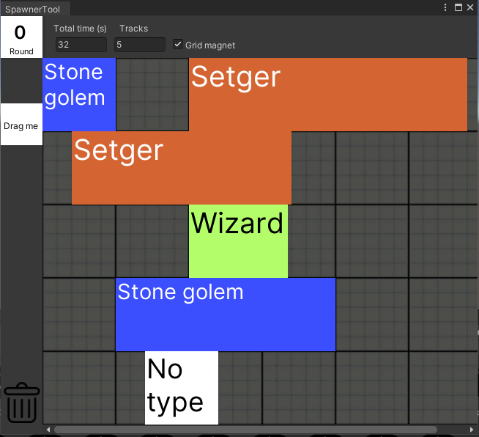
- Spawner tool window
  - Here you can configure each spawner graph.
  - You can open it with double click or from inspector of spawner graphs.
  - You can create spanwer graph in assets folder, right click, Create/SpawnerTool/SpawnerGraph.
  - You can open the window in tool bar as SpawnerTool/Spawner. If you don’t have any spawner graph, you can create one from there or select one that you already created.
  - This window features:
    - Quick access to any round, you can input text or scrollwheel.
    - Change round time, and add more tracks if you can’t suite enought enemy Blocks to it.
    - Drag & drop blocks (from Drag me block) to quickly setup enemies. You can change property blocks by selecting them and change settings in default inspector.
    - Drag & drop blocks to the top & left sides to delete the block. You can also delete blocks with Delete key.
    - Enable/disable grid magnet for more precission.
  - You can set up max rounds, time, total time, and even change background and block texture from a SpawnerTool window settings scriptable object.
- Wave Manager:
  - This component is the most important. It makes the spawn graph work.
  - Add it to a game object in the scene.
  - This component features:
    - It features events
1. When round finishes.
2. When all rounds finish.
3. When an enemy is spawned (with Enemy Gameobject as parameter).
    - Lets you configure multiple things of way it spawns.
- Spawn Points ID Manager
  - This component sets up spawn points, which Wave Manager uses to know where to spawn enemies with SpawnGraph id.
  - This component features:
    - Add child GameObjects to define spawn points.
    - It shows you in Scene editor position and number of spawn points id.
      - This can be diabled (when you don’t have SpawnPointsIdManager gameobject selected) and change color/fontSize.

- Enemy Factory scriptable object
  - This scriptable object exists to reference Prefabs of each enemy. In order to be able to add prefabs, there must be enemies set up within SpawnerTool project preferences.

Changelog

V1.0
- Release version.
- Basic example demo of tool configuration.

